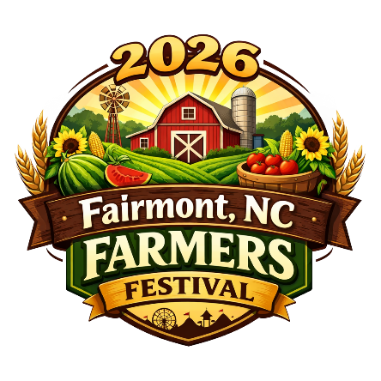
2026 Fairmont Farmers Festival
Saturday, October 17, 2026

Information Booth

YOU MUST BRING YOUR OWN TABLE AND CHAIRS. SPACE IS LIMITED, SO PLEASE LET US KNOW IF YOU PLAN TO USE A TENT.

CONTACT PERSON: __________________________________________________________________________________

ORGANIZATION: ____________________________________________________________________________________

MAILING ADDRESS: _________________________________________________________________________________

_________________________________________________________________________________

TELEPHONE NUMBER : (DAY)______________________________(NIGHT):__________________________________

FAX NUMBER: _________________________ EMAIL ADDRESS: __________________________________________

TENT: YES _______ NO ______

PLEASE USE THE SPACE BELOW TO TELL US ABOUT YOUR BOOTH. PLEASE PRINT OR TYPE.

_____________________________________________________________________________________________________

_____________________________________________________________________________________________________

_____________________________________________________________________________________________________

_____________________________________________________________________________________________________

PLEASE RETURN FORM BY MAIL TO: FAIRMONT FARMERS FESTIVAL
OR FAX: 910-628-6025 P.O. BOX 642 FAIRMONT, NC 28340

IF YOU HAVE ANY QUESTIONS, PLEASE CALL FESTIVAL CHAIRMAN CHANDA HUGHES, PHONE: 910-740- 8786
EMAIL: CORRACAT2000@GMAIL.COM
FESTIVAL EMAIL: town@fairmontnc.gov WEBSITE: www.fairmontnc.gov/fairmont-farmers-festival

DEADLINE FOR RECEIVING ENTRIES IS MONDAY, OCTOBER 5

YOU WILL BE NOTIFIED WHERE TO SET UP THE WEEK OF THE FESTIVAL.

