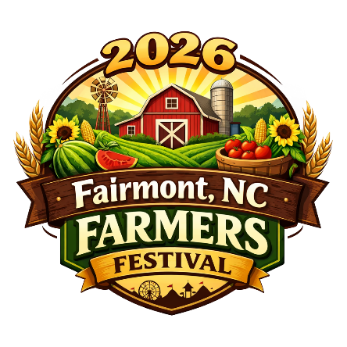
Fairmont Farmers Festival
Chanda Hughes, Festival Chairman
Jane Powell, Parade Coordinator
P.O. Box 642, Fairmont, NC 28340
(910) 280-2040
Email: town@fairmontnc.gov
Web: www.fairmontnc.gov/fairmont-farmers-festival

Dear Potential Parade Participant:

It’s time again to begin planning the annual Fairmont Farmers Festival Parade. The festival will be on Saturday, October 17, 2026, and the Parade will begin at 10:00 am. We greatly appreciate your interest and feel that you will be a great asset to our parade this year. The entry form is on the back on this letter. Please include a detailed description of your entry in the space provided. Please fill out as timely as possible if you are interested in participating this year. The Absolute Deadline for your entry is FRIDAY, OCTOBER 2nd! NO OTHER ENTRIES WILL BE ACCEPTED AFTER THIS DATE. NO ENTRIES WILL BE ALLOWED IN THE DAY OF THE PARADE! THERE WILL BE NO EXCEPTIONS!

We hope to see you on October 17. Further Information will be sent to you on or before the second week of October. Thank you once again for your interest!

Jane Powell, Parade Coordinator
(910) 280-2040
Email: town@fairmontnc.gov
Web: www.fairmontnc.gov/fairmont-farmers-festival

Type of Unit: __________________________________________________________________
(Band, Antique Car, Float, Queen, Tractor, Walking Unit, Etc.)
Contact Person: ________________________________________________________________

Mailing Address: _______________________________________________________________
_______________________________________________________________

Telephone Number (Day): ______________________ (Night): __________________________

Fax Number: ________________ Email Address: _____________________________________

PLEASE USE THE SPACE BELOW TO TELL US ABOUT THIS ENTRY AND ITS RIDERS SO THE ANNOUNCER MAY BETTER DESCRIBE YOUR UNIT AS IT PASSES THE REVIEWING STAND. PLEASE USE ADDITIONAL PAPER IF NECESSARY. PLEASE PRINT OR TYPE. CAR AND MOTORCYCLE CLUBS MUST LIST ALL VEHICLES AND DRIVERS.
________________________________________________________________________________________________________________________________________________________________________________________________________________________________________________________________________________________________________________________________________________

Please return form by mail to: Fairmont Farmers Festival
Or Fax: 910-628-6025 P.O. Box 642 Fairmont, NC, 28340

If you have any questions, please call Parade Coordinator Jane Powell at (910) 280-2040
Or Festival Chairman Chanda Hughes at (910) 740-8786, Email corracat2000@gmail.com
Festival Email: town@fairmontnc.gov Website: www.fairmontnc.gov/fairmont-farmers-festival

DEADLINE FOR RECEIVING ENTRIES IS FRIDAY, OCTOBER 2, 2026. THERE IS NO CHARGE TO PARTICIPATE IN THE PARADE EXCEPT FOR QUEENS, WHICH IS $20 A CAR. FLOAT RENTAL IS $500 AND CAN BE SPILT BETWEEN TWO OR MORE SPONSORS.

An information packet with the parade lineup, a street map, and instructions will be emailed to the address you have indicated above on or before October 12th.
Please note that all queens must provide their car, driver, and signs.

There is absolutely no throwing of candy or other objects from vehicles in parade. Violators will be pulled from the parade lineup.

ALL ENTRIES MUST ADHERE TO APPLICABLE MOTOR VEHICLE LAWS. Dangerous behavior such as burnouts and wheelies will be enforced with fines! Drivers are reminded that this is a family friendly event and are asked not to play music with explicit language. For safety reasons, horses will not be allowed this year!

